**SUPPLEMENTARY MATERIAL**

**Table 1:** Trends in antimicrobial resistance across drug classes from 2016 to 2021.

|  |  |  |  |  |  |  |
| --- | --- | --- | --- | --- | --- | --- |
| **Year** | **Drug Class** | | | | | |
| Aminoglycoside | Lactamase Inhibitor | Fluoroquinolone | Polymyxin | Carbapenem | Tetracycline |
| 2016 | 77 |  | 95 | 106 | 90 | 12 |
| 2017 | 52 |  | 71 | 91 | 76 | 15 |
| 2018 | 74 |  | 91 | 116 | 92 | 5 |
| 2019 | 57 |  | 76 | 84 | 78 | 10 |
| 2020 | 40 |  | 55 | 71 | 48 | 10 |
| 2021 | 66 |  | 81 | 88 | 79 | 21 |

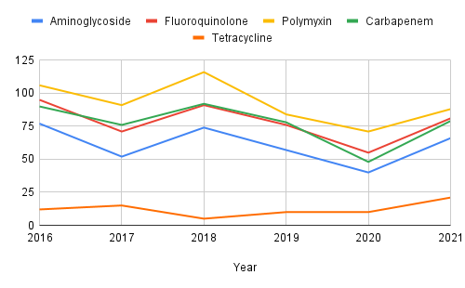

**Figure 1:** Trends in antimicrobial resistance across drug classes from 2016 to 2021. From 2016 to 2021, resistance trends fluctuate but show no consistent decline, indicating a persistent problem. Notably:

* Polymyxin resistance peaked in 2018.
* Carbapenem resistance remained high throughout
* Tetracycline resistance increased significantly in 2021.

**Table 2:** Comparison of specimen types between resistant and susceptible patients.

|  |  |  |
| --- | --- | --- |
| **Specimen Type** | **Resistance** | **Not Resistance** |
| Bodily fluids: Abdominal | 5 | 1 |
| Bodily fluids: Bile | 1 |  |
| Bodily fluids: Peritoneal | 15 | 6 |
| Bodily fluids: Thoracentesis | 2 | 1 |
| CVS: Blood | 92 | 28 |
| GI: Abscess | 6 | 1 |
| GI: Appendix | 1 |  |
| GI: Gall Bladder | 6 | 1 |
| GI: Large Colon | 1 | 1 |
| GI: Liver | 1 |  |
| GI: Pancreas | 3 |  |
| GI: Stomach | 1 |  |
| GU: Kidneys |  | 1 |
| GU: Urinary Bladder | 1 |  |
| GU: Urine | 46 | 10 |
| INT: Abscess | 2 | 1 |
| INT: Decubitus | 1 |  |
| INT: Furuncle |  | 1 |
| INT: Other | 3 |  |
| INT: Skin Ulcer | 1 |  |
| INT: Wound | 15 | 1 |
| Respiratory: Bronchial brushing | 5 | 2 |
| Respiratory: Bronchials | 6 | 1 |
| Respiratory: Bronchoalveolarlavage | 23 | 2 |
| Respiratory: Endotrachealaspirate | 123 | 9 |
| Respiratory: Lungs | 2 | 1 |
| Respiratory: Other |  | 1 |
| Respiratory: Sputum | 89 | 40 |
| Respiratory: Trachea | 11 | 3 |
| Unknown | 1 |  |

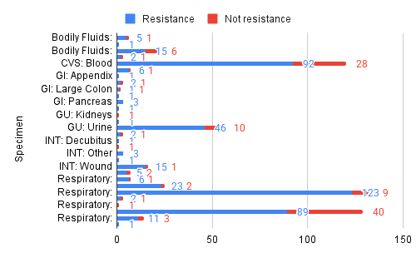

**Figure 2:** Comparison of specimen types between resistant and susceptible patients. Respiratory specimens account for the highest number of resistant cases, especially endotracheal aspirates (123) and sputum samples (89). Blood samples also show a high number of resistant isolates.

**Table 3:** Total numbers of Resistant and Drug-susceptible Cases, 2016–2021.

|  |  |  |
| --- | --- | --- |
| **Year** | **Resistance** | **Not resistance** |
| 2016 | 89 | 21 |
| 2017 | 72 | 23 |
| 2018 | 92 | 27 |
| 2019 | 78 | 8 |
| 2020 | 48 | 24 |
| 2021 | 80 | 9 |
| Total | 459 | 112 |

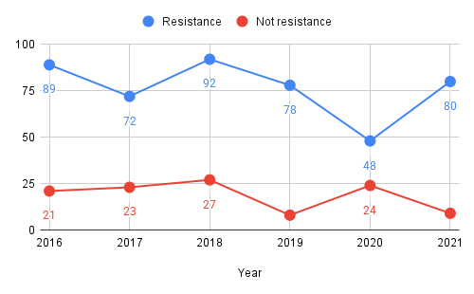

**Figure 3:** Total numbers of Resistant and Drug-susceptible Cases, 2016–2021. Out of 571 total cases based on the observed regions, approximately 80% (459) of isolates were resistance. While 2020 saw a dip in resistance (possibly due to lower sample counts during the pandemic), the trend resurged in 2021.

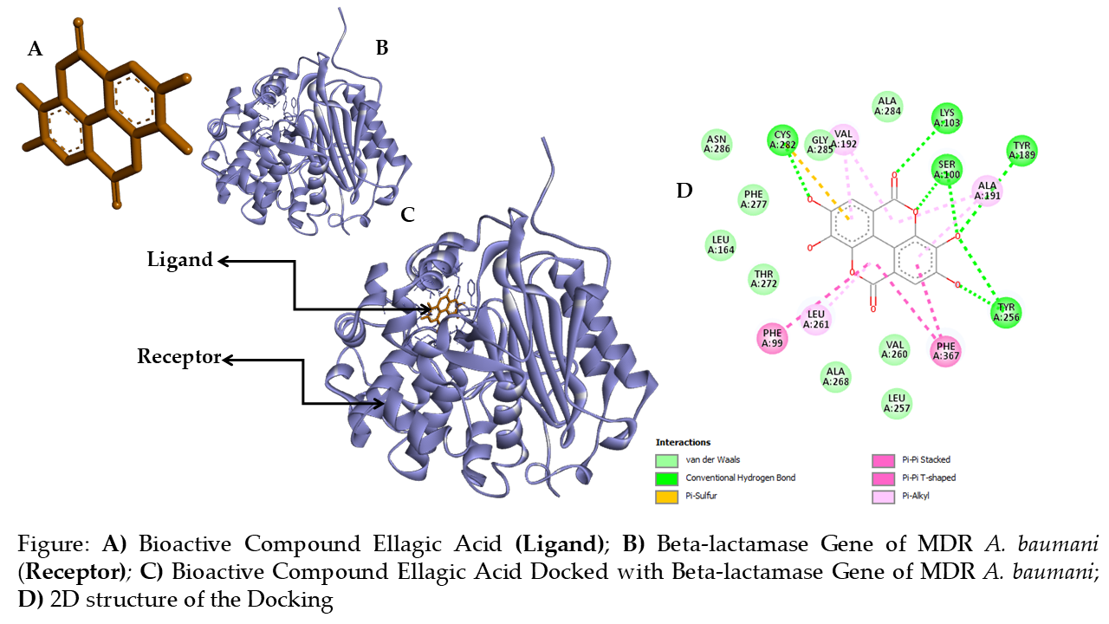

**Figure 4:** **Docking Result** **A)** Bioactive Compound Ellagic Acid **(Ligand)**; **B)** Beta-lactamase (*OXA-51*) Gene of MDR *A. baumannii* (**Receptor)***;* **C)** Bioactive Compound Ellagic Acid Docked with Beta-lactamase (*OXA-51*) Gene of MDR *A. baumannii*; **D)** 2D structure of the Docking

**C**

**D**

**B**

**A**

**Figure 5:** **A)** Bioactive Compound Caffeic Acid **(Ligand)**; **B)** Beta-lactamase (*OXA-51*) Gene of MDR *A. baumannii* (**Receptor)***;* **C)** Bioactive Compound Caffeic Docked with Beta-lactamase (*OXA-51*) Gene of MDR *A. baumannii*; **D)** 2D structure of the Docking

**A**

**B**

**C**

**D**

**Figure 6: A)** Bioactive Compound Ferulic Acid **(Ligand)**; **B)** Beta-lactamase (*OXA-51*) Gene of MDR *A. baumannii* (**Receptor)***;* **C)** Bioactive Compound Ferulic Docked with Beta-lactamase (*OXA-51*) Gene of MDR *A. baumannii*; **D)** 2D structure of the Docking

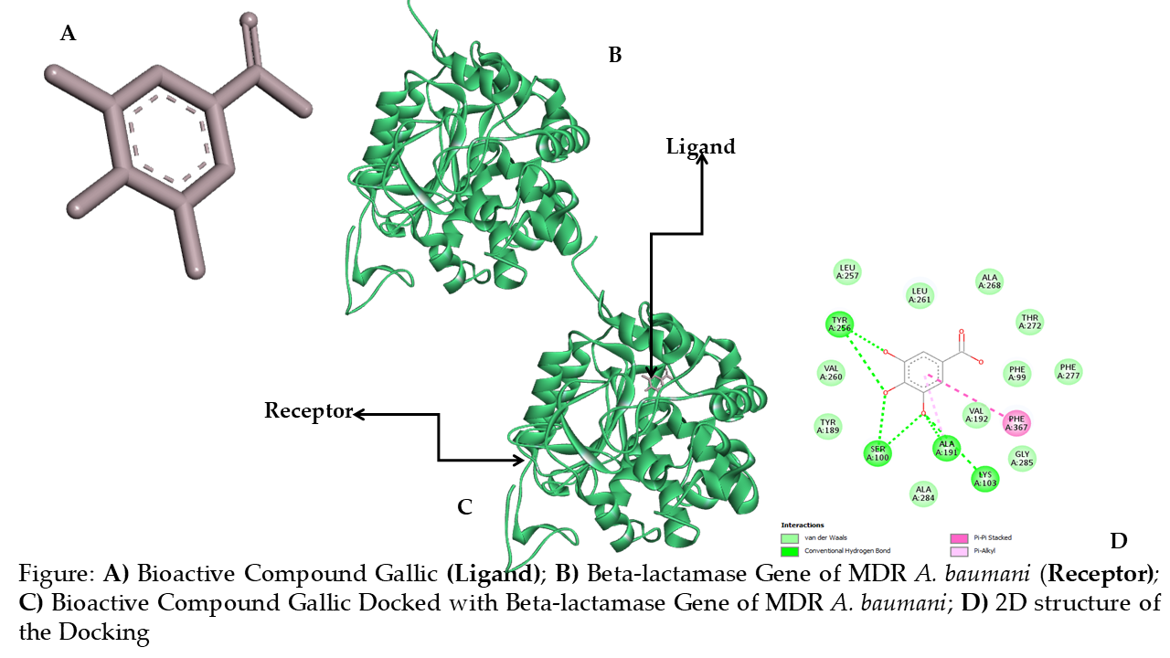

**Figure 7: A)** Bioactive Compound Gallic Acid **(Ligand)**; **B)** Beta-lactamase (*OXA-51*) Gene of MDR *A. baumannii* (**Receptor)***;* **C)** Bioactive Compound Gallic Docked with Beta-lactamase (*OXA-51*) Gene of MDR *A. baumannii*; **D)** 2D structure of the Docking

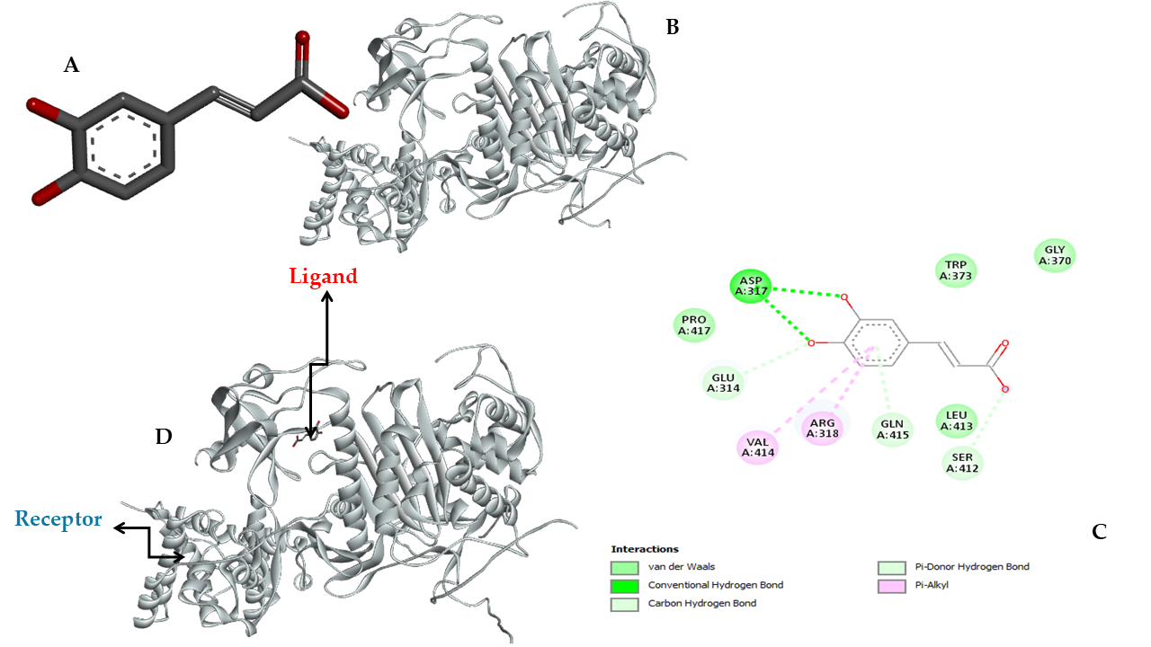

**Figure 8: A)** Bioactive Compound Caffeic Acid **(Ligand)**; **B)** Penicillin Binding Protein (*PBP1a*) Gene of MDR *A. baumannii* (**Receptor)***;* **C)** 2D structure of the Docking **D)** Bioactive Compound Caffeic Docked with Penicillin Binding Protein (*PBP1a*) Gene of MDR *A. baumannii*

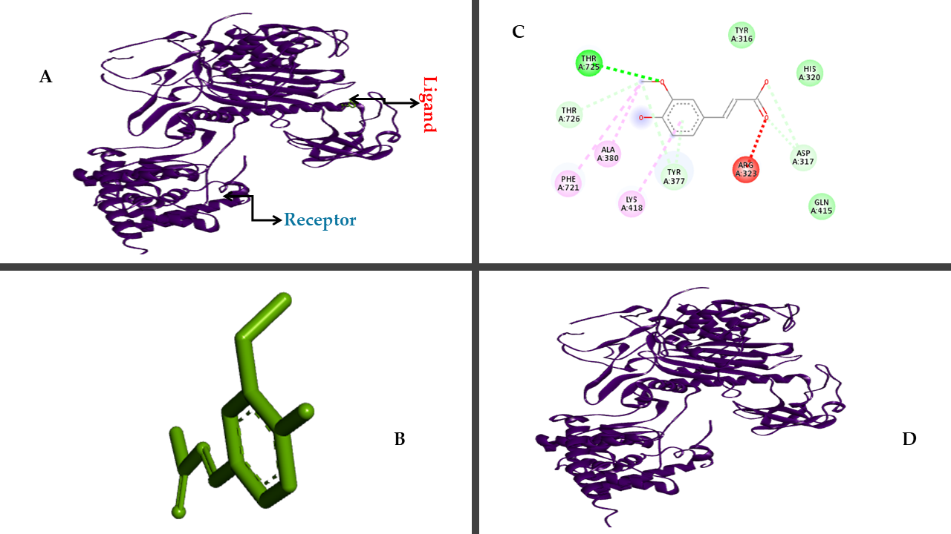

**Figure 9: A)** Bioactive Compound Ferulic Docked with Penicillin Binding Protein (*PBP1a*) Gene of MDR *A. baumannii* (**Receptor)***;* **B)** Bioactive Compound Ferulic **(Ligand)**; **C)** 2D structure of the Docking **D)** Penicillin Binding Protein (*PBP1a*) Gene of MDR *A. baumannii*

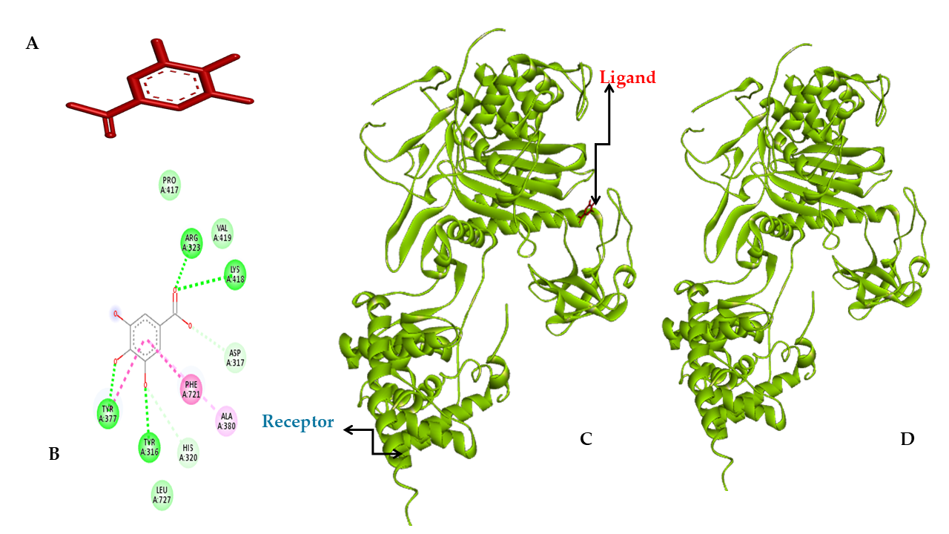

**Figure 10: A)** Bioactive Compound Gallic **(Ligand)**; **B)** 2D structure of the Docking **C)** Bioactive Compound Gallic Docked with Penicillin Binding Protein (*PBP1a*) Gene of MDR *A. baumannii*; **D)** Penicillin Binding Protein (*PBP1a*) Gene of MDR *A. baumannii* (**Receptor).**

**Table 4:** *Acinetobacter baumannii* Resistance Genes Outer membrane protein A (*OmpA*) and Lipid A biosynthesis (*LpxC*) Against four bioactive compounds from two medicinal plants (*Senna alata and Psidium guajava*).

|  |  |  |  |
| --- | --- | --- | --- |
| ***A. Baumannii* Genes And Bioactive Compounds** | **Docking Score** | **Confidence Score** | **Ligand Rmsd** |
| *OmpA Gallic Acid* | -141.79 | 0.4590 | 15.50 |
| *OmpA Ferulic Acid* | -124.51 | 0.3752 | 16.12 |
| *OmpA Ellagic Acid* | -177.80 | 0.6355 | 15.94 |
| *OmpA Caffeic Acid* | -141.37 | 0.4570 | 15.38 |
| *LpxC* *Gallic* | -117.69 | 0.3438 | 11.74 |
| *LpxC* *Ferulic* | -118.67 | 0.3483 | 12.93 |
| *LpxC* *Ellagic* | -155.80 | 0.5290 | 13.40 |
| *LpxC* *Caffeic* | -119.99 | 0.3543 | 12.02 |

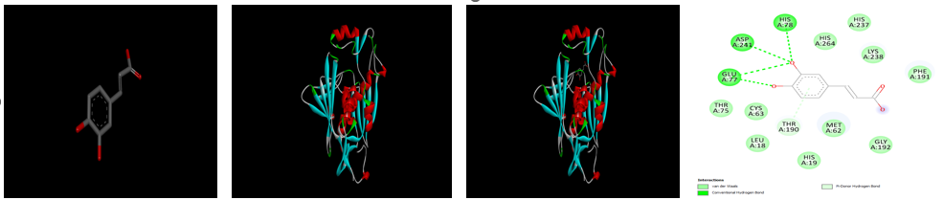

**D**

**C**

**A**

**B**

**Figure 12: A)** Bioactive Compound Caffeic Acid **(Ligand)**; **B)** Lipid A biosynthesis (*LpxC*) Gene of MDR *A. baumannii* (**Receptor) C)** Bioactive Compound Caffeic Acid Docked with Lipid A biosynthesis (*LpxC*) Gene of MDR *A. baumannii* **D)** 2D structure of the Docking

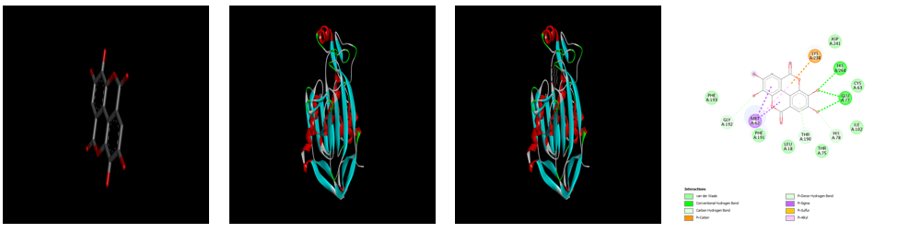

**D**

**A**

**B**

**C**

**Figure 13: A)** Bioactive Compound Ellagic Acid **(Ligand)**; **B)** Lipid A biosynthesis (*LpxC*) Gene of MDR *A. baumannii* (**Receptor) C)** Bioactive Compound Ellagic Acid Docked with Lipid A biosynthesis (*LpxC*) Gene of MDR *A. baumannii* **D)** 2D structure of the Docking

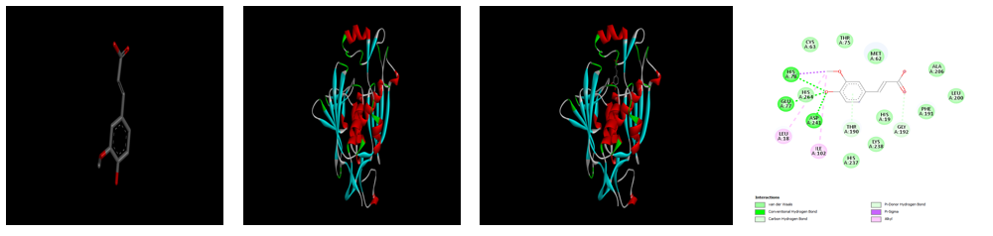

**D**

**C**

**B**

**A**

**Figure 14: A)** Bioactive Compound Ferulic Acid **(Ligand)**; **B)** Lipid A biosynthesis (*LpxC*) Gene of MDR *A. baumannii* (**Receptor) C)** Bioactive Compound Ferulic Acid Docked with Lipid A biosynthesis (*LpxC*) Gene of MDR *A. baumannii* **D)** 2D structure of the Docking

**D**

**B**

**A**

**C**

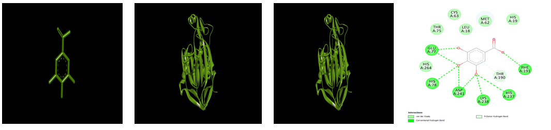

**Figure 15: A)** Bioactive Compound Garlic Acid **(Ligand)**; **B)** Lipid A biosynthesis (*LpxC*) Gene of MDR *A. baumannii* (**Receptor) C)** Bioactive Compound Garlic Acid Docked with Lipid A biosynthesis (*LpxC*) Gene of MDR *A. baumannii* **D)** 2D structure of the Docking

**D**

**C**

**B**

**A**

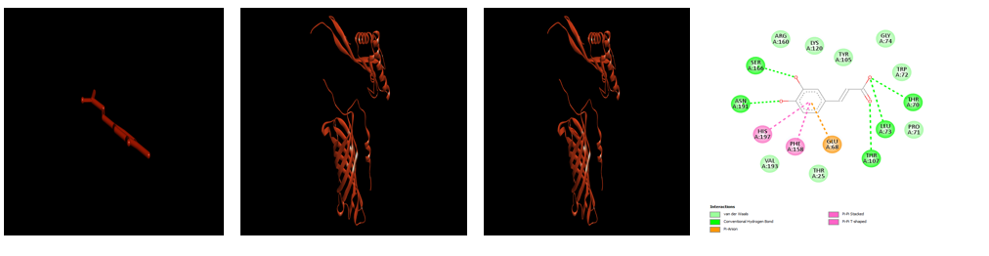

**Figure 16: A)** Bioactive Compound Caffeic Acid **(Ligand)**; **B)** Outer membrane protein A (*OmpA*) Gene of MDR *A. baumannii* (**Receptor) C)** Bioactive Compound Caffeic Acid Docked) with Outer membrane protein A (*OmpA*) Gene of MDR *A. baumannii* **D)** 2D structure of the Docking

**D**

**Ac**

**B**

**C**

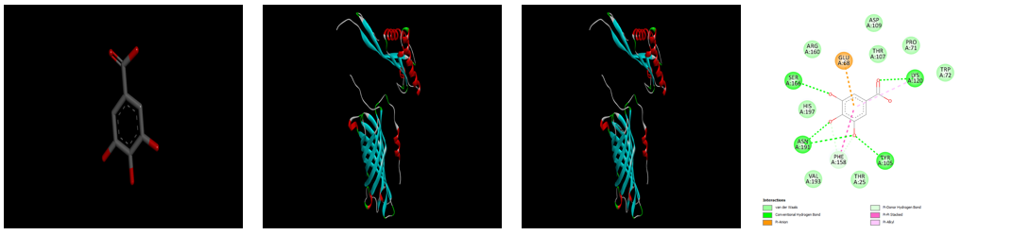

**Figure 16: A)** Bioactive Compound Garlic Acid **(Ligand)**; **B)** Outer membrane protein A (*OmpA*) Gene of MDR *A. baumannii* (**Receptor) C)** Bioactive Compound Garlic Acid Docked) with Outer membrane protein A (*OmpA*) Gene of MDR *A. baumannii* **D)** 2D structure of the Docking

**D**

**C**

**B**

**A**

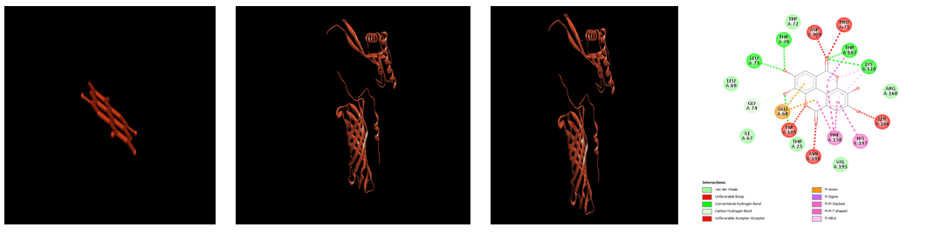

**Figure 17: A)** Bioactive Compound Ellagic Acid **(Ligand)**; **B)** Outer membrane protein A (*OmpA*) Gene of MDR *A. baumannii* (**Receptor) C)** Bioactive Compound Ellagic Acid Docked) with Outer membrane protein A (*OmpA*) Gene of MDR *A. baumannii* **D)** 2D structure of the Docking

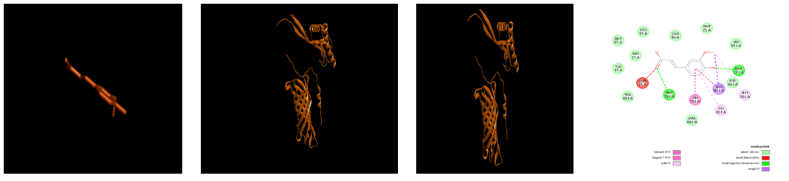

**D**

**C**

**B**

**A**

**Figure 17: A)** Bioactive Compound Ferulic Acid **(Ligand)**; **B)** Outer membrane protein A (*OmpA*) Gene of MDR *A. baumannii* (**Receptor) C)** Bioactive Compound Ferulic Acid Docked) with Outer membrane protein A (*OmpA*) Gene of MDR *A. baumannii* **D)** 2D structure of the Docking

**Table 5:** *Acinetobacter baumannii* Resistance Gene DNA gyrase (*GyrB* subunit) Against four bioactive compounds from two medicinal plants (*Senna alata and Psidium guajava*.

|  |  |  |  |
| --- | --- | --- | --- |
| *A. baumannii* Genes and Bioactive Compounds | Docking Score | Confidence Score | Ligand Rmsd |
| *GyrB* Ferullic Acid | -115.24 | 0.3329 | 18.35 |
| *GyrB* Caffeic Acid | -112.32 | 0.3200 | 18.28 |
| *GyrB* Ellagic Acid | -157.99 | 0.5399 | 20.02 |
| *GyrB* Gallic Acid | -113.97 | 0.3273 | 47.07 |

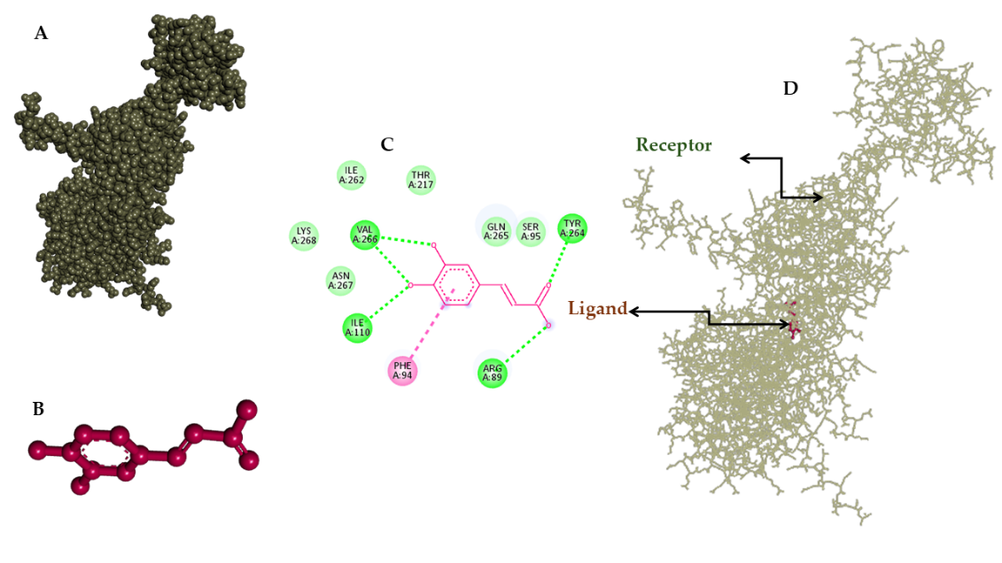

**Figure 18: A)** Bioactive Compound Caffeic Acid **(Ligand)**; **B)** DNA gyrase (*GyrB* subunit) Gene of MDR *A. baumannii* (**Receptor) C)** Bioactive Compound Caffeic Acid Docked) with DNA gyrase (*GyrB* subunit) Gene of MDR *A. baumannii* **D)** 2D structure of the Docking

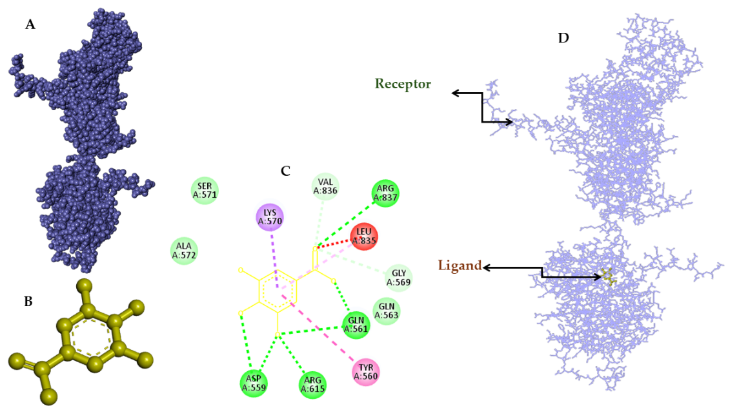

**Figure 19: A)** Bioactive Compound Garlic Acid **(Ligand)**; **B)** DNA gyrase (*GyrB* subunit) Gene of MDR *A. baumannii* (**Receptor) C)** Bioactive Compound Garlic Acid Docked) with DNA gyrase (*GyrB* subunit) Gene of MDR *A. baumannii* **D)** 2D structure of the Docking

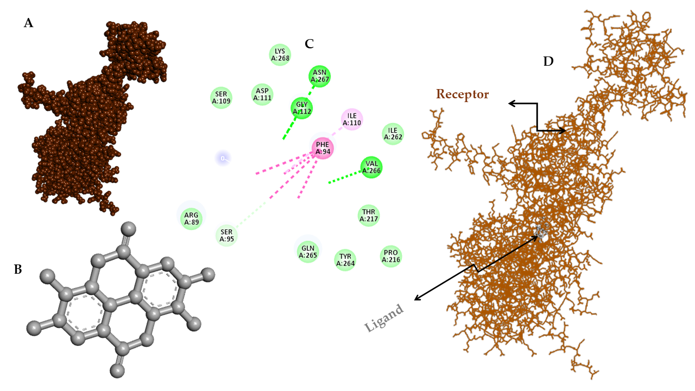

**Figure 20: A)** Bioactive Compound Ellagic Acid **(Ligand)**; **B)** DNA gyrase (*GyrB* subunit) Gene of MDR *A. baumannii* (**Receptor) C)** Bioactive Compound Elllagic Acid Docked) with DNA gyrase (*GyrB* subunit) Gene of MDR *A. baumannii* **D)** 2D structure of the Docking

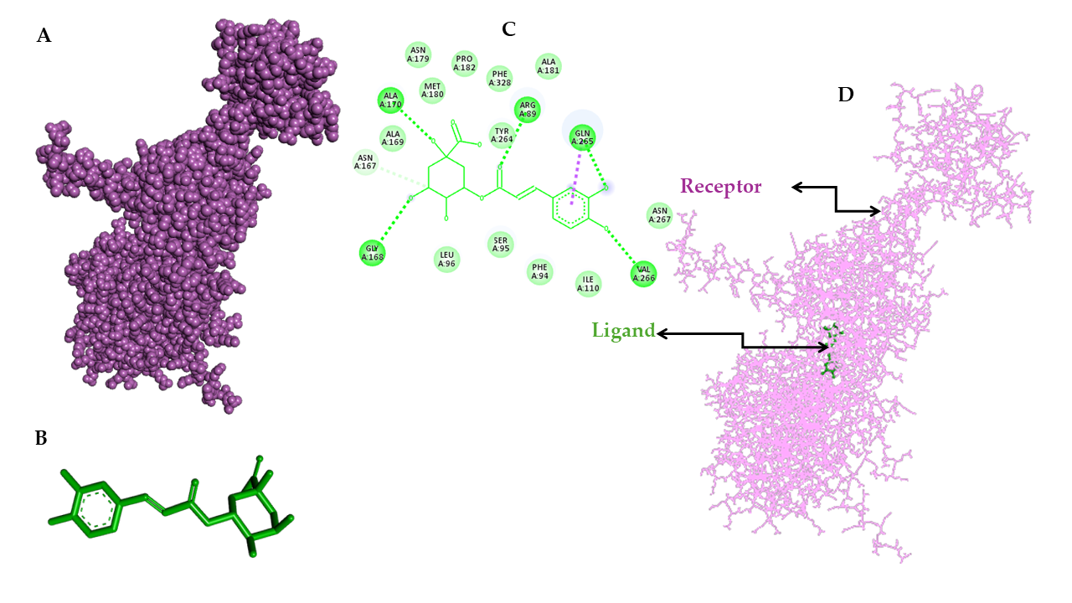

**Figure 21: A)** Bioactive Compound Ferulic Acid **(Ligand)**; **B)** DNA gyrase (*GyrB* subunit) Gene of MDR *A. baumannii* (**Receptor) C)** Bioactive Compound Ferulic Acid Docked) with DNA gyrase (*GyrB* subunit) Gene of MDR *A. baumannii* **D)** 2D structure of the Docking